Name; adding a new product into the system

Steps;

|  |  |
| --- | --- |
| actor | system |
| 1 choose command “add product”  Main screen; | “add product” |
| 3 input data then click “add” button “add product ” screen with data | 4 Hid “add product ” screen and display “add product Successfully!” screen  “add product Successfully!” screen |
| Click on “ok” buttom | Display “main” screen |

Name; adding a new customer into the system

Steps;

|  |  |
| --- | --- |
| actor | system |
| 1 choose command “add Customer”  Main screen; | “add customer” |
| 3 input data then click “add” button “add customer ” screen with data | 4 Hid “add customer ” screen and display “add customer Successfully!” screen  “add customer Successfully!” screen |
| Click on “ok” buttom | Display “main” screen |

Name; Add Purchase into the system

Steps;

|  |  |
| --- | --- |
| actor | system |
| 1 choose command “Add Purchase”  Main screen; | “add purchase” |
| 3 input data then click “add” button “add purchase ” screen with data | 4 Hid “add Purchase ” screen and display “add Purchase Successfully!” screen  “add Purchase Successfully!” screen |
| Click on “ok” buttom | Display “main” screen |

2 -

products

suppliers

buy

products

buy

customersss

3.

Products have kinds of information about products.

Customers is customers’ information.

Purchases is write down the information that buy products from kinds of supplier.

Products (productID, barcode, name, price, taxRate)

Customers (customrID, name, address, phone, paymentInfo)

Purchases (purchaseID, productID, customerID, quantity, totalCost)

4.5

Customers (customrID, name, address, phone)

CREATE TABLE "Customers" (

"customrID" INTEGER NOT NULL,

"name" TEXT,

"address" TEXT,

"phone" INTEGER,

PRIMARY KEY("customrID")

);

INSERT INTO Customers (customrID, name, phone, adress)

VALUES

(2, ‘dd’, ‘911’,dds),

(3, ‘ccc, ‘1112’,sdd),

(4, ‘ss’, ‘2222’,m78),

(5, ‘zz, ‘22222’,nss7),

(6, ‘qq’, ‘1223’,aaa1),

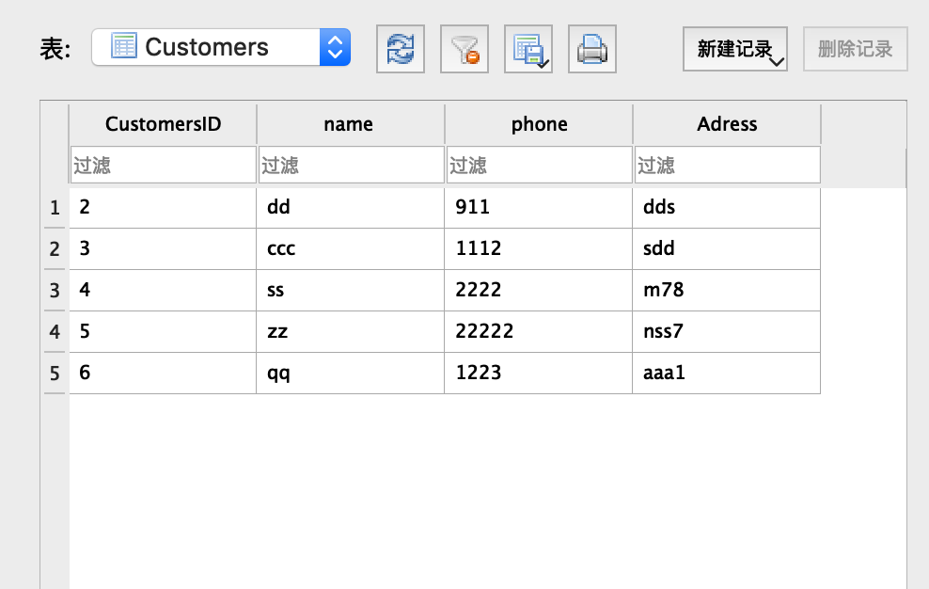

Products (productID, barcode, name, price, taxRate, supplier)

CREATE TABLE "Products" (

"productID" INTEGER NOT NULL,

"barcode" INTEGER,

"name" TEXT,

"price" REAL,

"taxRate" REAL,

PRIMARY KEY("productID")

);

INSERT INTO Products (productID, barcode, name, price, taxRate)

VALUES

(2, 11, ‘orange’, 1.1, 100),

(3, 22, ‘banana, 2.2, 100),

(4, 33, ‘coke, 3.3, 100),

(5, 44, ‘pear’, 1.11, 100),

(6, 55, ‘apple, 12.3 100),

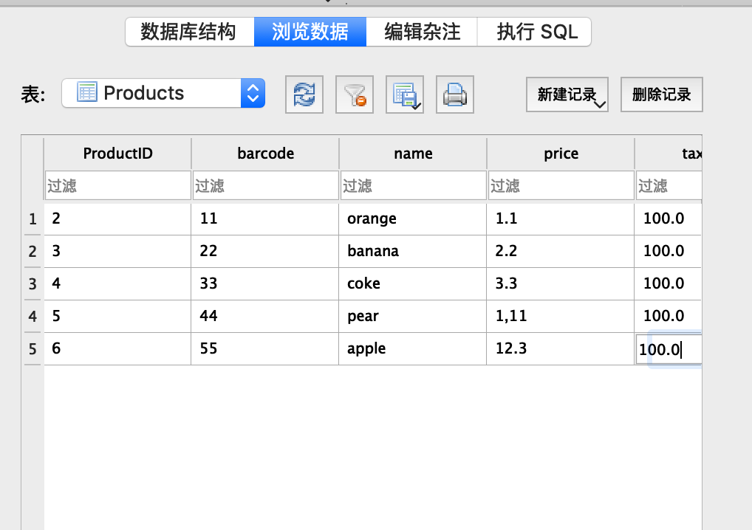

Purchases (purchaseID, productID, customerID, quantity, totalCost)

CREATE TABLE "Purchases" (

"purchaseID" INTEGER NOT NULL,

"productID" INTEGER NOT NULL,

"customerID" INTEGER NOT NULL,

"quantity" INTEGER,

"totalCost" REAL,

PRIMARY KEY("purchaseID")

);

INSERT INTO Purchases (purchaseID, productID, customerID, quantity, totalCost)

VALUES

(2,2,3,1,100),

(3,3,4,1,100),

(4,4,5,1,100),

(5,5,6 ,1,100),

(6,6,7,1,100),

(7,7,8,1,100),

(8,8,9,1,100),

(9,9,10,1,100),

(10,10,11,1,100),

